How to use SQL Server spatial results to draw pictures

The premise is quite simple, to draw something in SSMS using the spatial results tab. The easiest way to do this is to pick an image and convert it into something that SQL Server can understand.
My intent was to provide you with some guidance on how to create your own image in SQL Server Management Studio, and I provide this further in this article.
First though I want to cover how much we need to know to make something like this work.
You need to know:
- What spatial data is
- What Well-know Text is
- What the differences is between vector and raster images
- How to drive a vector editing tool, like Inkscape
- How to handle layers
- How to edit text files
- How to write SQL code

That’s quite a bit. Even assuming that you have the knowledge you need to bring it all together in a usable way. This set of instructions that follow is not exhaustive. The entire is. From start to finish I have invested roughly 100 hours just to get to a point where I can bring a reasonable set of instruction together in a way that most people with most of the “need to knows” will likely be able to follow.

What I want to get out of this is that by showing how I get to the solution, someone else will find a better way. The use case I present is quite basic, copy an image. The solution however is not bound to replication of image. Once you have a set of elements there is nothing limiting you from moving them around, or adding conditions to what gets presented in SSMS.
Let’s cover some of the basics first.
What is spatial data
The spatial results tab is focussed on, well, viewing spatial data type results. These data types are grouped into geometry (flat plane, like a paper) and geography (ellipsoidal, like the Earth).
We encounter spatial results all the time, just open a navigation app on a smartphone. Spatial data is used in rendering the map. All those maps and all the elements they include. Spatial data is used to render the roads and features. We’re talking continents, countries, cities, streets, buildings, lakes and the everything in between. Every object in these maps are representations of an object as it would exist on a surface, in this case the Earth. All of these representation are made using geometry and geography shapes and how they are positioned on a plane.
Maps are just 2D representations of shapes on a map. The coordinates, latitude and longitude, of each item links to a point on the map.
Spatial Data Types Overview
https://docs.microsoft.com/en-us/sql/relational-databases/spatial/spatial-data-types-overview
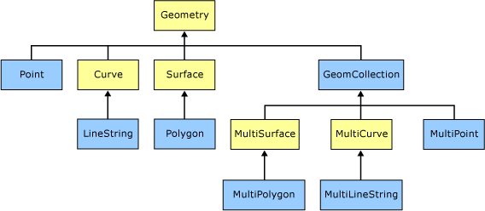

Polygons and lines are used to create representations of our world and we can use them to create some basic images. All we must do is manipulate these geo data building blocks into some shapes.

Enter the humble vector image.
But images are images right. Right? It turns out that how we see the world can be quite complex to visually capture and then recreate digitally. There are 2 main types of images used to represent images that we encounter every day. Raster and vector graphics.
Raster image are made from little pixels and each pixel has a position and a color associated with it. JPG, PNG and GIF image formats are raster formats.
Vector images are made up of shapes, and you’ll find them lurking inside SVG, EPS, PDF and AI files. Vectors are everywhere.
Take your mobile phone for example. Your selfies and pictures are raster pictures, your app icons on your phone are normally vector.
Vectors are like maps, but instead of mapping object based on latitude and longitude you have points on a canvas.
“Vector graphics are computer graphics images that are defined in terms of 2D points, which are connected by lines and curves to form polygons and other shapes”. - Wikipedia
If vector images are lines and polygons on a fixed size canvas all we have to do is to convert a vector image’s component shapes on the canvas into an equivalent representation of those components on a map using coordinates.
SSMS offers a framework for interpreting those spatial shape and presenting them on a map. It is pretty much up to our imagination to decide what type of shapes we want SSMS to render. There is no real limit to the type of shapes that can rendered, if they fall within the limitations of the framework.
What I will be describing below is a simple framework that can be used to convert images between formats and convert them to spatial data.

There is always a price to pay. This conversion is a trade-off and is done at the loss of quality to gain functionality. Complex images are hard and can take a tremendous amount of time to clean up and sanitise before converting them to spatial data. Colours are hard to reproduce in the current versions of SSMS. All of this is a compromise, and in my opinion totally worth it.
By now you should have a good idea of what spatial data is and how we plan to convert in image to a vector so we split out to object.
This sounds a lot easier than I’m making it out to be.

OK. Let’s do this.
So SSMS can render simple shapes, gotcha. All we have to do is break a complex image into component parts and reassemble them in SSMS, so it’s like Lego.

Lego is easy, just ask Emmet.
To start we will use this picture and convert it from a raster image into a vector.

Step 1. Choose an image.
Pick your champion. For the purpose of explanation, and sticking to the building block theme, I have picked a simple image. More colours and detail add’s complexity, so it would be advisable to keep complex images on the bench for now.
Step 2. Convert your image to SVG format.
I use Inkscape for this, https://inkscape.org/. There are many great sources that talk about conversion using Inkscape, so detailed instructions on how to carry this out falls outside of the scope of this article. I recommend saving the file as a plain SVG. Editors will add their own metadata, which may or may not impact the conversion process.
If you cannot find good conversion tools, just start with an existing SVG.

Step 3. Clean up the SVG file.
This can be a labor intensive process, but this is the most important step.
Cleaning up the SVG requires all curves to be converted to straight lines. I have been unable to reliably get Curved Polygon shapes converted, which leads to this recommendation. Converting the SVG to SQL code works best when you only have polygons with straight lines. There is also a lot of work in removing small artefacts that you might not need in the final vector.
The easiest way to get this done is with Inkscape. In my case I am selecting the “Edit path by nodes (F2)” option, the left red circle. Then I select all, Edit > Select All, and then clicking on the “make selected segments lines”, highlighted below by the top red circle.
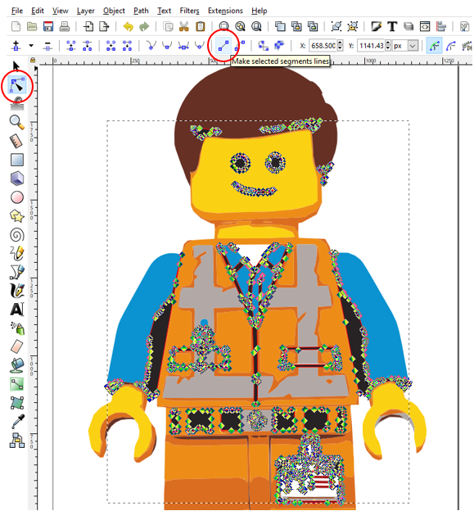

And you end up with an image that looks a lot like the one below. In fact, here is the link to the SVG file.


Step 4. Looking inside the SVG.
You now have a well formed SVG file containing all the objects that need to be converted.
Crack open the SVG file using your favourite text editor. You will notice that SVG files are just XML files. The <path> elements are each an object within the final SVG render. The d attribute inside the path defines a path to be drawn.
Here is a snippet
<path d="m 414.70534,1921.9386 0.32323,-4.3687 2.27689, ..”
Let me translate the snippet below. “To draw this path move the start point to <414.70534>,<1921.9386> . Now draw a line to coordinates <0.32323>,<-4.3687>. From this point draw a line to the next set of coordinates and so on.
So each path contains instructions on how to draw the element. Each <path> element will become a a polygon.
Tip: Find the following character “ c “, with the spaces. If you find this in the document edit the SVG to remove the curve to elements. These point to curved lines and conversions of curved lines cause havoc.

Step 5. Converting to Well-Known Text
Up to now we have working with SVG data, now we need to turn it into something that SQL server can understand.
We will be using an online converter https://mygeodata.cloud/converter/svg-to-wkt.

If you are using your own SVG file please note that the SVG file needs to be modified before uploading. This is a requirement of the online converter we will be using. Add the bit of code between </metadata>.. and ..<defs
</metadata>
<MetaInfo xmlns="http://www.prognoz.ru"><Geo><GeoItem X="-595.30" Y="-142.88" Latitude="37.375593" Longitude="-121.977795"/><GeoItem X="1388.66" Y="622.34" Latitude="37.369930" Longitude="-121.959404"/></Geo></MetaInfo>
<defs

Upload your file and convert it.

Step 6. CSV to SQL.
Converting the file will return a CSV file containing a row for each layer in the SVG.

Step 7. It’s up to you.
You now have SQL script to generate each polygon in SSMS.

Step 8. Layering.

Back to the apple.
There have been forays into converting vector images into shapes, but this has been edge cases with limited implementations. Drawing a Christmas tree is fun, but pretty much bound to a certain time of year.

